Please use your ap_*userid* database where you have privileges to make changes.

1. Create a view name open_items that shows the invoices that have not been paid.

This view should return four columns from the Vendors and Invoices tables:

vendor_name

invoice_number

invoice_total

balance_due (invoice_total – payment_total – credit_total)

Show SQL code and result here from view creation, then show result set from extracting from the table (select * from open_items). (12 pts)



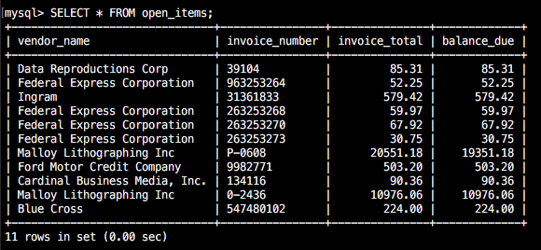

1. Write a SELECT statement that returns all of the columns in the opem_items view that you created in Q1, with one row for each invoice that has a balance_due of $1,000 or more.

Show SQL code and result set here. (10 pts)

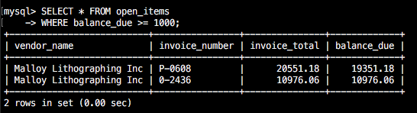

1. Create a view named open_items_summary that returns one summary row for each vendor that has invoices that have not been paid.

Each row should include

vendor_name

open_item_count (the number of invoices with a balance due)

open_item_total (the total of the balance due amounts)

The rows should be sorted by the open item totals in descending sequence.

Show SQL code and result here from view creation, then show result set from extracting from the table (select * from open_items_summary). (12 pts)

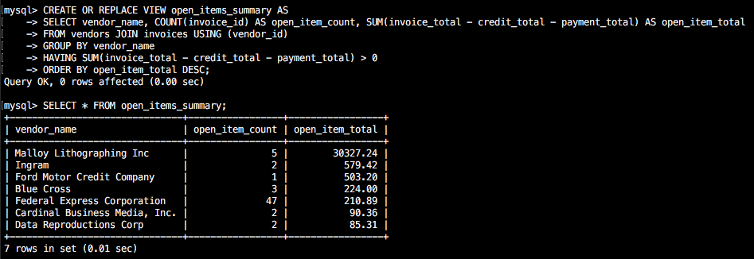

1. Write a SELECT statement that returns just the first 5 rows from the open_items_summary view that you created in Q3.

Show SQL code and result set here. (10 pts)

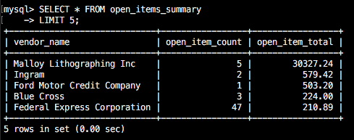

1. Create an updatable view named vendor_address that returns following columns for each vendor:

vendor_id

vendor_address1

vendor_address2

vendor_city

vendor_state

vendor_zip_code

Show SQL code and result here from view creation, then show result set from selecting the view. (select * from vendor_address, clip first few, last + total lines). (12 pts)

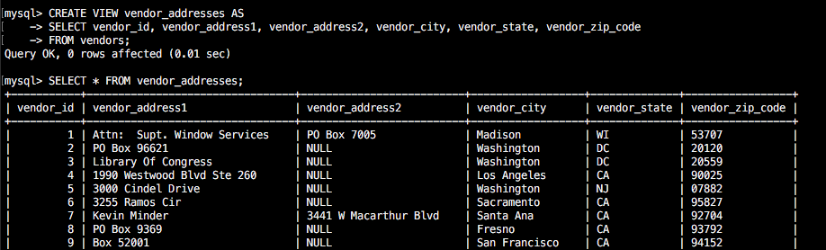

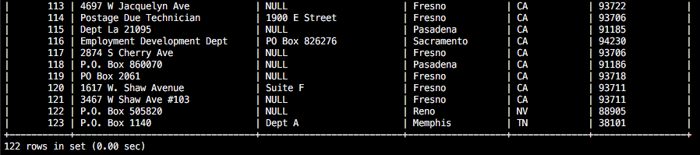

1. Write a SELECT statement to show the row from vendor_address where the vendor_id = 4.

Show SQL code and result here.

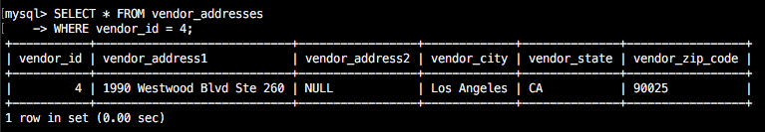

Write an UPDATE statement that changes the address for the row with a vendor ID of 4 so that suite number (Ste 260) is stored in the vendor_address2 column instead of the vendor_address1 column.

Show SQL code and result from UPDATE and the SQL code and result from a SELECT to show only vendor_id = 4. (12 pts)

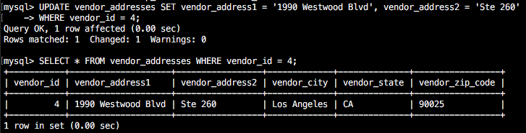

1. Issue a command to list all of the tables and views and their table_type that are in your database.

Show SQL code and result here (10 pts)

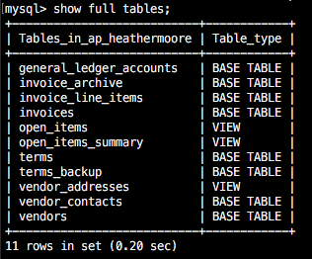

1. When a database administrator gives, or takes away, privileges for users, they use the GRANT and REVOKE commands.  Write two brief paragraphs in *YOUR OWN WORDS* giving the syntax for these two statements and explaining their many uses.  (do not cut/paste from the internet). (20 pts)

GRANT gives privileges to individual mysql users. Database administrators have the option of giving all privileges or a combination of privileges such as SELECT, INSERT, UPDATE, or DELETE. A user who is granted all privileges will also have the ability to create and drop tables, indexes, and views. This can be applied to any table within the database that the administrator is working with. The syntax to apply this is:

GRANT privilege_list

ON [db_name.]table

TO user1 [IDENTIFIED BY ‘password1’]

[GRANT OPTIONS];

Here the privilege_list would be replaces with what privileges you are granting (ex: ALL, SELECT, INSERT, UPDATE, DELETE, USAGE) db_name would be replaced with the database name or *.* for the global level, user1 would be the user you want to give privileges to, and password1 would be their password

REVOKE is much the same as GRANT except that you are taking away privileges in the case that a user abuses their rights to the access of the data. Database administrators have the option of revoking all or some privileges. The syntax for REVOKE is:

REVOKE privilege_list

FROM user1;

Here the privilege_list would list the privileges that you are revoking (ex: ALL, UPDATE, DELETE, INSERT, SELECT) When revoking all privileges, you must also include GRANT OPTIONS in the privilege list because you will be revoking the user’s grant options as well.